To Split all the worksheets from excel to individual files. Follow these steps:

Where to run the code?

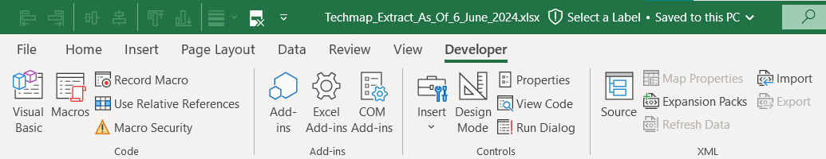

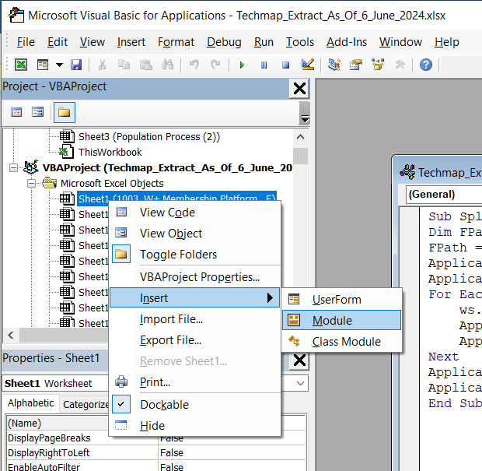

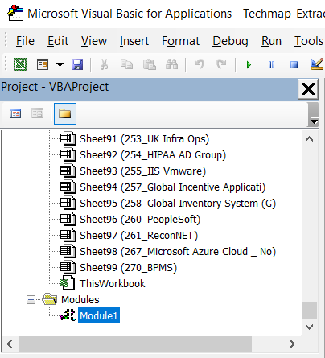

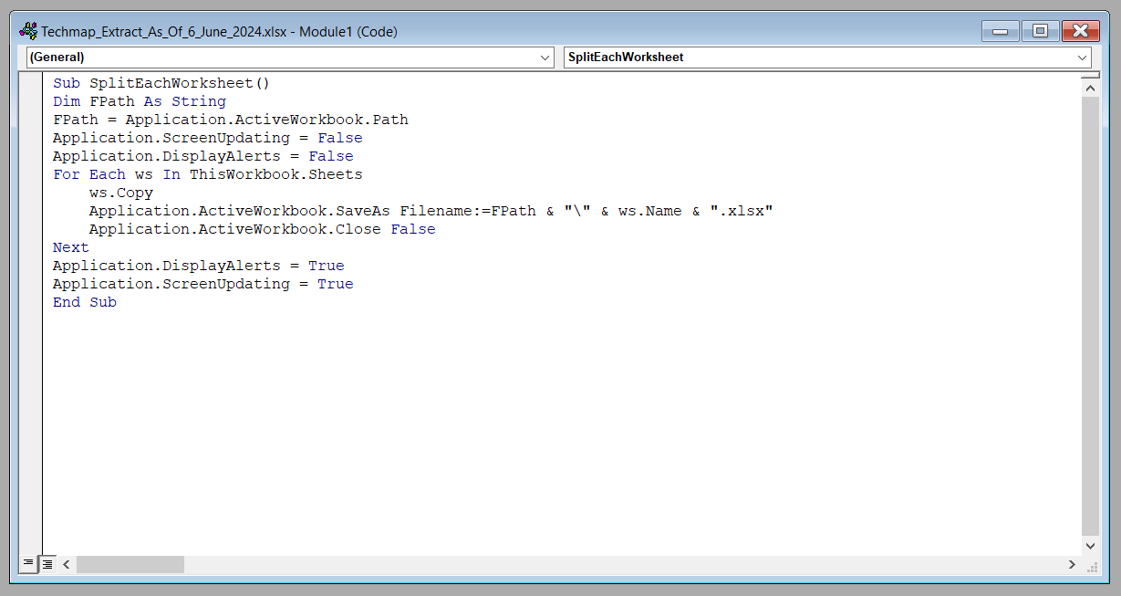

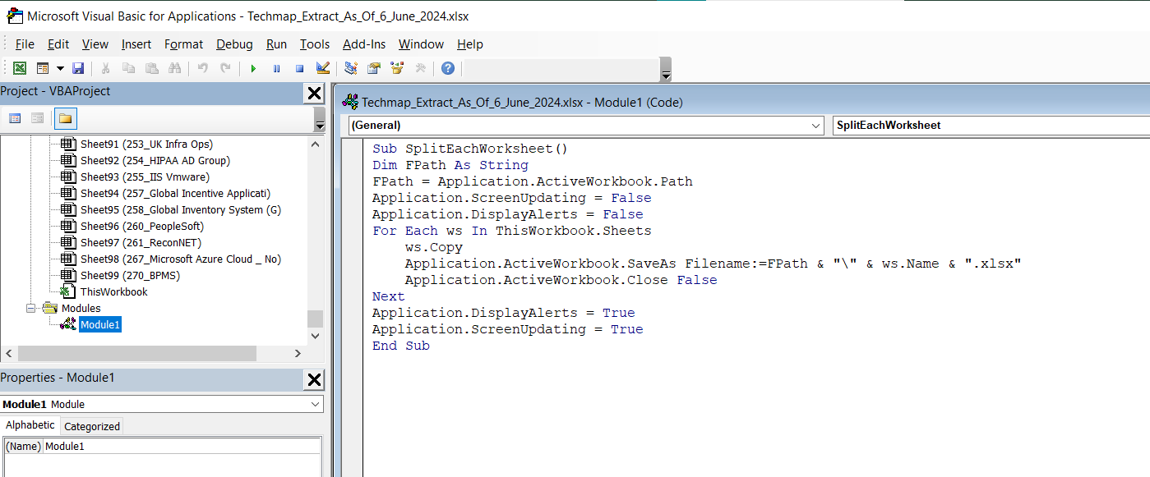



***The Code:***

Sub SplitEachWorksheet()

Dim FPath As String

FPath = Application.ActiveWorkbook.Path

Application.ScreenUpdating = False

Application.DisplayAlerts = False

For Each ws In ThisWorkbook.Sheets

ws.Copy

Application.ActiveWorkbook.SaveAs Filename:=FPath & "\" & ws.Name & ".xlsx"

Application.ActiveWorkbook.Close False

Next

Application.DisplayAlerts = True

Application.ScreenUpdating = True

End Sub